UCD School of Computer Science and Informatics

COMP20170 Introduction To Robotics

**ROBOTICS ESSAY**

**IRON MAN MARK IV 3D PRINTED HAND**

**Author:** Fergal Lonergan **Student Number: 13456938**

## Declaration

I declare that the work described in this report was done by the people named above, and that the description and comments in this report are my own work, except where otherwise acknowledged. I have read and understand the consequences of plagiarism as discussed in the COMP School Policy on Plagiarism, the UCD Plagiarism Policy and the UCD Briefing Document on Academic Integrity and Plagiarism. I also understand the definition of plagiarism.

Signed: Fergal Lonergan Date: 25/4/15

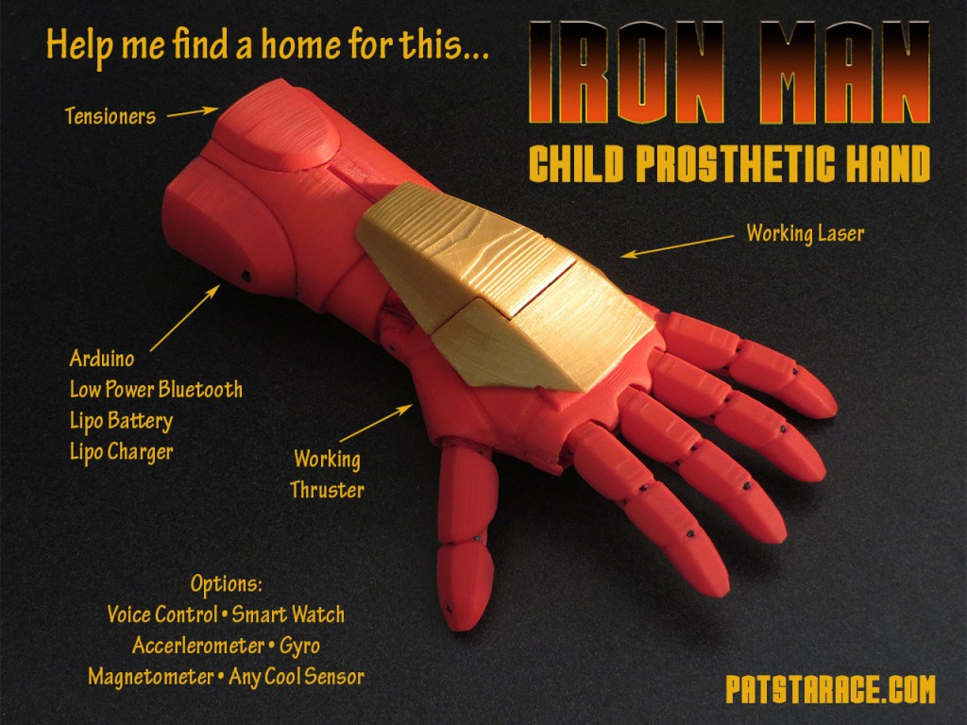

Table of Contents

Declaration 1

Functionality of Robot 3

Software 3

Hardware 4

Technology 5

Artificial Intelligence (AI) techniques implemented 5

Application and critique 5

Comparison to similar solutions (if they exist) 6

Market need for this robot, future usage and potential. 6

References 7

## Functionality of Robot

The functionality of the “Iron Man Mark IV Prosthetic Hand” is incredible and goes way above the usual requirements for a prosthetic hand. The “Mark IV” is equipped with tensioners in the wrist mount, a type of force sensor which enables the Arduino micro-controller on-board to distinguish the different muscle groups being used in order to interpret the user’s desired outcome for the hand. It also has “NinjaFlex rubber fingers” which are placed on the fingertips of each finger in order to improve grip as well as a “Touch Stylus” forefinger for use on any tablet or mobile device. It is also secured with a rubber covered Velcro strap which ensures that the hand fits snugly and securely to the wearer at all times as well as maintaining a sleek finish.  
The hand is powered by a rechargeable Lipo battery which powers the Arduino, the lasers which activate when the hand is bent into a fist shape, the LED’s and small motor that creates the “thruster” in the palm, the infrared lights which can be programmed to be used as a universal remote for any infrared device, as well as the low power Bluetooth, nine degree of freedom accelerometer, gyroscope and wrist sensors all housed in the “Mark IV”.  
The low powered Bluetooth is used to connect to a mobile app which can then be used to simulate the values of different sensors on-board which also gives a 3D simulation of the hand and its movement. The app also has a built in alert function that vibrates the hand and lights up the “thrusters” so that the hand can be located if it is ever misplaced as well as a mode for use in therapy and diagnostics or just mobile game play.   
The Arduino micro-controller also the Arduino learning platform as well as accessible pins and a 4x4 protoboard so the user can begin to learn “Blinky” in an extremely hands on way as well as allowing for modifications to be made to the hand in order to increase functionality later on. The cover of this is magnetic for ease of access. There is also a magnet in the finger tips in order to pick up small magnetic objects that may be difficult to pick up considering the fingers are comprised of a hard 3D printed plastic.  
The “Mark IV” can also be adjusted to the user’s needs in order to match their muscle strength etc. for use when adjusting tensioner settings.

## Software

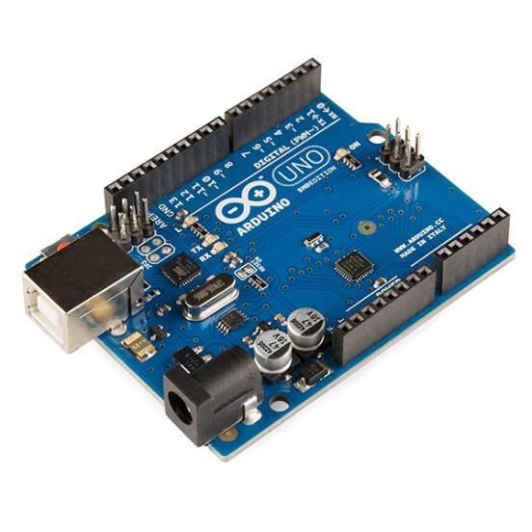 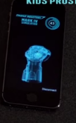 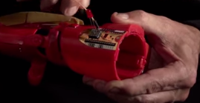

The Arduino micro-controller is a cross platform device which makes it extremely easy to code. Arduino have their own programming language which is completely open source and can be expanded by the addition of C++ libraries. The exact details of the code are unknown however what we do know is that the “Mark IV” takes in inputs from the nine degree of freedom accelerometer, the gyroscope, the tensioners in the wrist as well as the force sensors embedded along the fingers and the rotational wrist sensors. This then returns outputs to the actuators in the wrist and finger joints as well as the thrusters, infrared lights, lasers, and also transfers the data from the sensors to the mobile app in order to create a 3D model of the “Mark IV”.   
The mobile app demonstrated is for apple iStore and I was unable to find to find the app on the Google play store which makes me assume that it has only been written for the iStore. For this reason I assume the app is written in XCode a very common iOS platform language. However it would not be difficult to rewrite the programme in order for it to work cross-platform.   
The “Mark IV” also has the unique feature where the user is able to learn “Blinky” the Arduino learning platform language on board the device, opening the For this reason I assume the app is written in XCode a very common iOS platform language. However it would not be difficult to rewrite the programme in order for it to work cross-platform.   
The “Mark IV” also has the unique feature where the user is able to learn “Blinky” the Arduino learning platform language on board the device, opening the young wearer to the world of programming and handing them the building blocks to one day manipulate the code on their “Mark IV” in order to increase its functionality to suit them.

## Hardware

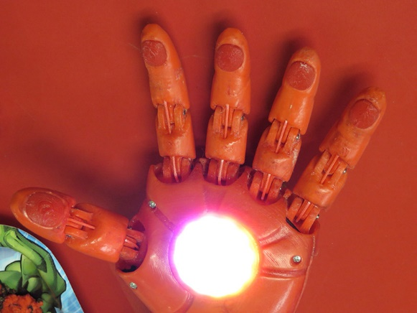 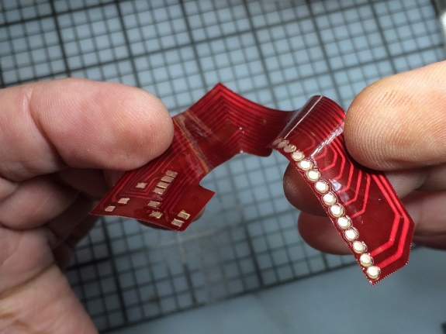

The “Mark IV” has many outstanding features, but probably the most impressive of these are hardware related. First of all the entire exoskeleton has been 3D printed and the plans for these are available to those in need of them. Pat Starace, the creator of the “Iron Man Prosthetic Hand”, is also desperate to spread his technology to those in need and as a result has made the “Mark IV” as cheap as possible whilst maximising its functionality. This is why he has decided to 3D print the hand, first of all to drive down costs, but secondly to ensure that each “Mark IV” can be custom built to suit each individual.   
However this in itself poses its own problem, one to which Starace found an ingenious solution. You see if the scale of the “Mark IV” changes, as far as the exoskeleton is concerned you need only rescale the hand on a program like SolidWorks or Google SketchUp etc. This however is not applicable to the internal circuitry. Furthermore where Starace to use regular silicon circuit boards he would have to increase both the size and the weight of the “Mark IV”. In order to combat this Starace made flexible circuit boards, a tutorial for which he has in his website, out of pyralux sheets, before etching the circuit paths and finally covering it all in a “Hot-Rod red” mask to ensure that should any of it be visible through the exoskeleton that it would go un-noticed and not take away from the visual aspect of the “Mark IV”.   
The “Mark IV” is also equipped with a nine degree of freedom accelerometer, gyroscope, a rotational wrist sensor, and tensioners in the wrist as well as small force sensors in the fingers. On top of this the “Mark IV” boasts a 4x4 exposed protoboard for learning “Blinky”, a “thruster” in its palm, infrared lights as well as laser LED’s which are revealed when you make the shape of a fist and a touch stylus index finger and magnetic fingers for increased functionality. All of which are powered by the rechargeable Lipo battery.   
The “Mark IV” has been built with excessive amounts of hardware to achieve the functionality it has at the minute and this is so that it can be updated with improved software versions without needing to change the hardware, which has become the standard for most technological devices these days.  
It has the ability to even be used as a smartwatch, as well as be voice controlled, as it has a small built in microphone which was not utilised in this version.

## Technology

The “Mark IV” houses an on-board Arduino micro-controller which contains the program for the entire hand. It reads in the data from the multitude of sensors on board the “Mark IV” before interpreting it and returning the desired output to the different elements on-board the hand.   
The “Mark IV” also makes use of one of the newest pieces of widespread technology used in the field of robotics, which is 3D printing. The entire exoskeleton is 3D printed from a durable lightweight plastic which makes the “Mark IV” extremely cheap when compared to other competitors whilst still matching, and sometimes eclipsing, their functionality.  
There is also the ability to programme the “Mark IV” to be used as a universal remote control and make use of the low powered Bluetooth capabilities in order to utilise the “Mark IV” as a games controller.

## Artificial Intelligence (AI) techniques implemented

The “Mark IV” receives multitudes of data from its myriad of sensors detailed above and processes this all in the Arduino micro-controller before returning the desired outputs. Most of the input for use is read from the tensioners in the wrist. These read the contractions of muscles and interpret them in the Arduino before sending data to the actuators in the wrist and fingers causing them to react accordingly by bending the fingers or wrist appropriately. There are also small force sensors in the fingers which read the reactant force placed on the fingers in order to ensure that the fingers or actuators are not broken. This is the same in the wrist joint.   
The gyroscope and accelerometer are also used to track the hands movement on the app which can then be used for optimisation and calibration of the “Mark IV” and its’ sensors.

## Application and critique

The “Mark IV” and all of the “Iron Man Prosthetic Hands” were designed for kids as a way to break down the fear for young children to start using prosthetics as well as combat the stigma surrounding prosthetics for children. It attempts to relieve the isolation felt by children forced to use prosthetic limbs and instead give them a cool alternative which could be used to boost their confidence. For its’ price the functionality of the “Mark IV” really is something to behold, however with the technology already in place to improve on its current functionality, the “Mark IV” is only a software update away from not only close copper fastening itself as a market leader in child prosthetics, but also paving itself a path into the realm of the leaders in prosthetics worldwide.   
Despite this what the “Mark IV” lacks in functionality it more than makes up for in personality and no doubt achieves its purpose by empowering those children in need of a prosthetic hand.

## Comparison to similar solutions (if they exist)

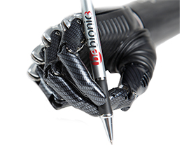

The Market leader at the moment for prosthetic hands is the “bebionic3”. It has a much more in-depth and impressive functionality with slip detection, improved grip, three wrist positions and foldaway fingers to name but a few. However, where it falls down is that the “bebionic3” has been for an adult and not a child and so its exoskeleton, appearance and size parameters are all designed to suit adults.   
The “Mark IV” is targeting the children’s market by attempting to make a prosthetic limb fun and enjoyable. Other alternatives like the “bebionic3” have extremely slick, but harsh looking exoskeletons which really can’t compare when placed against the like of the “Mark IV”. Starace is attempting to break the stigma and fear in children in wearing prosthetic limbs and instead of making them a clear sign of a disability, creating an object of envy for other kids. Seeing as it is the only dedicated prosthetic limb for children with this type of functionality and playfulness I feel it just can’t be matched by competitors.  
Another huge factor is the price with models like the “bebionic3” costing in the range of $25,000-35,000 whereas the “Mark IV” claims to be available for under $1000 a massive difference.

## Market need for this robot, future usage and potential.

There are more than 1.6 million people in the U.S people in the United states alone who use prosthetic limbs, a significant of those are children, so the market need for a prosthetic limb like this is immense. Not only does the Mark IV reduce the stigma around disability in children, especially for those in need of prosthetic limbs, but it has the ability to raise the child’s self-esteem to “Super-Human Levels”.   
The functionality of the limb is unrivalled and when coupled with its ability to be used as a universal remote control, the ability to learn code on board the hand in a unique hands on approach, the ability to build on the original firmware and software in order to increase functionality for the specific user i.e. utilising the Bluetooth and infrared capabilities of the Mark IV in order to make an on-board video game controller etc., as well as the dexterity and precision of the hand movement, the possible uses for this technology are almost endless.   
Personally I would love to see a matt black version that could be scaled up in order to be used for adults as well as children as due to the fact that the Mark IV is 3D printed the price is extremely low in comparison to other prosthetic limbs. Obviously certain aspects like the “thrusters” etc. could be removed for an adult version but the basic premise and scales could stay almost the exact same.   
I don’t feel like a foot would be as marketable as the hand, however, there is no doubt that if there were a market, the technology used could easily be implemented in the design of an “Iron Foot” or any other prosthetic limb for that matter.

## References

<http://www.patstarace.com>

<http://www.patstarace.com/iron-man-3d-printed-childs-hand.html>

<http://www.patstarace.com/armor-upgrade-iron-man-mark-iv-kids-prosthetic-hand.html>

<http://www.patstarace.com/making-a-flexible-printed-circuit-board-with-pyralux.html>

<https://www.adafruit.com/products/1894>

<http://www.arduino.cc/en/guide/introduction>

<http://www.amputee-coalition.org/inmotion/nov_dec_05/pros_rehab_tech_seniors.html>

<http://inhabitat.com/the-bebionic3-prosthetic-hand-is-powerful-enough-to-hold-99-pounds-and-sensitive-enough-to-use-a-pen/>